1.Create a S3 bucket, with no public access and upload files to the bucket & view the logs using CloudWatch for the uploaded files.
S3 Bucket create files are uploaded
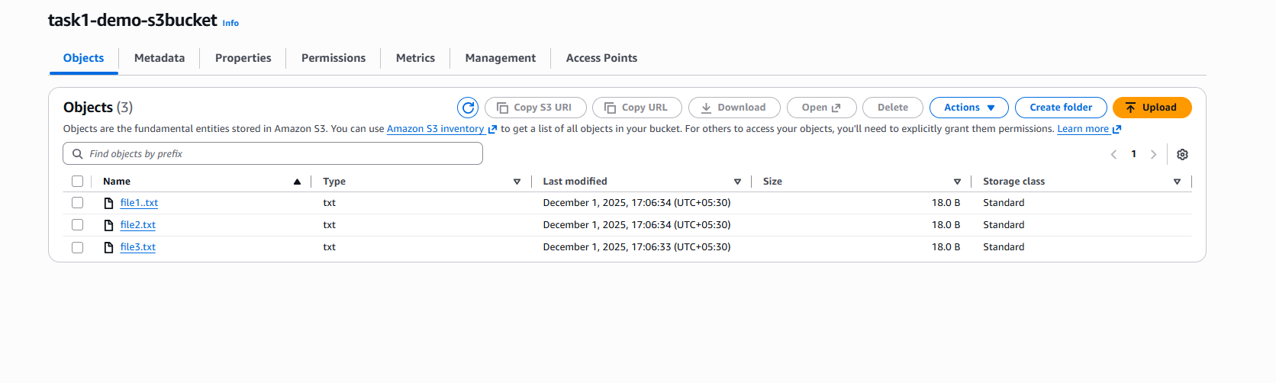

Cloud Trails created
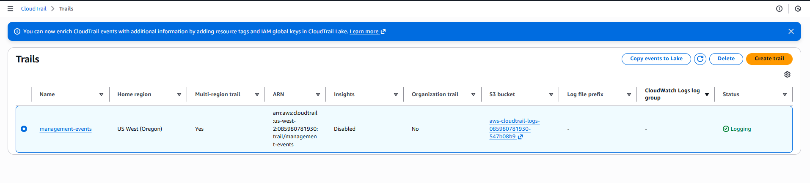
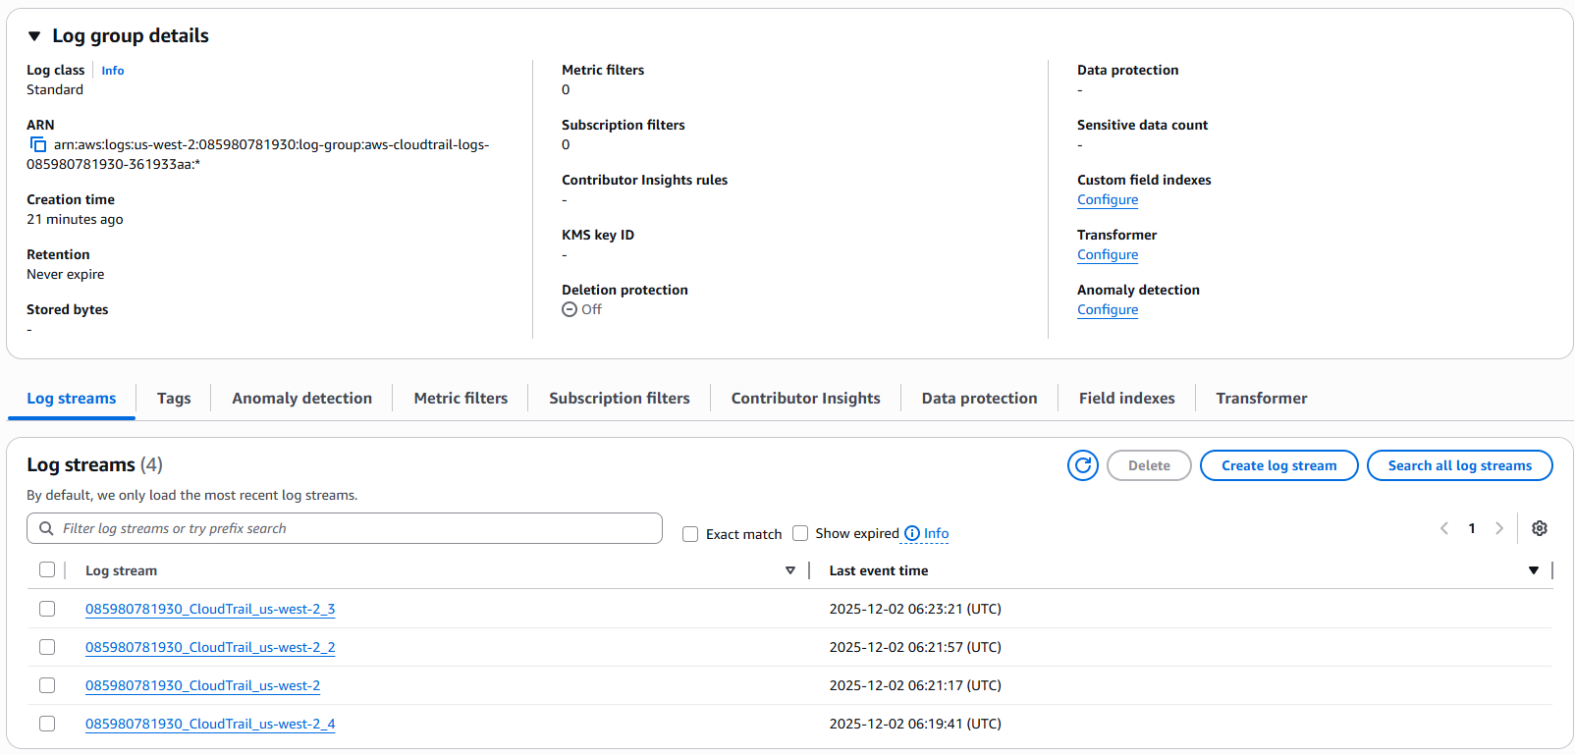
Log evets on cloud watch after uploading a new file event
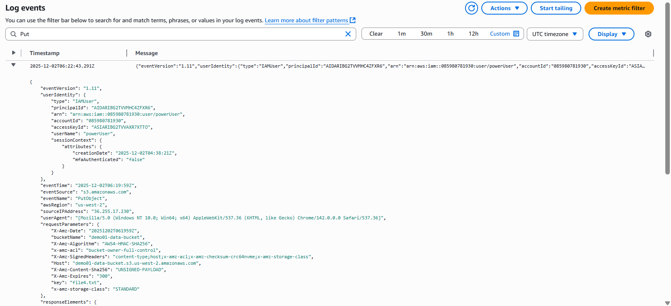
- After deleting an object
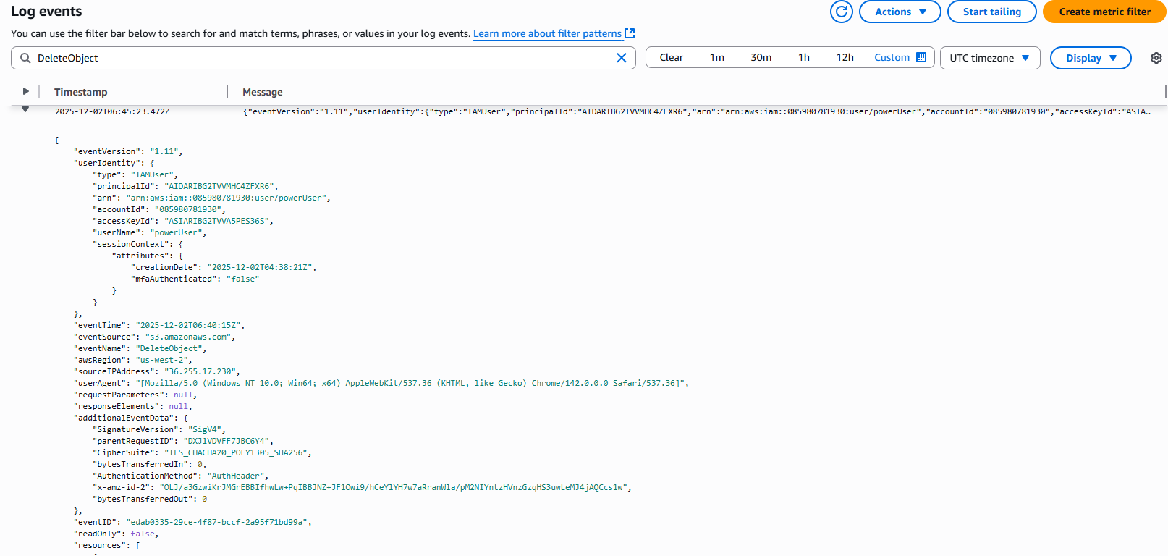
2.Launch two ec2-instances and connect it to a application load balancer, where the output traffic from the server must be an load balancer IP address
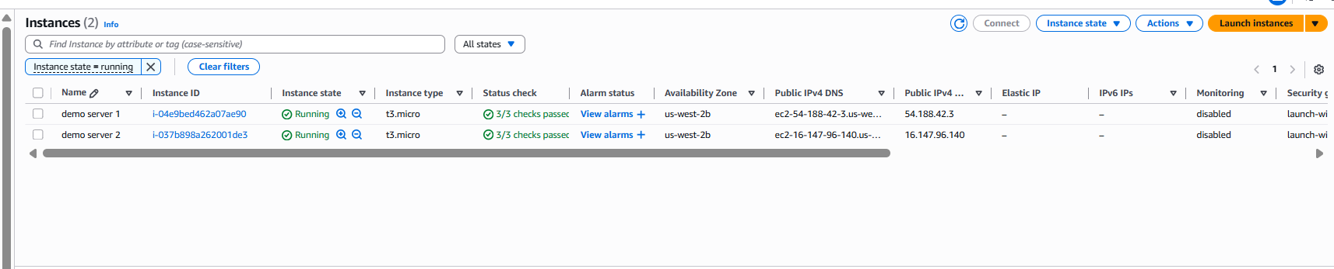
Security Group rules
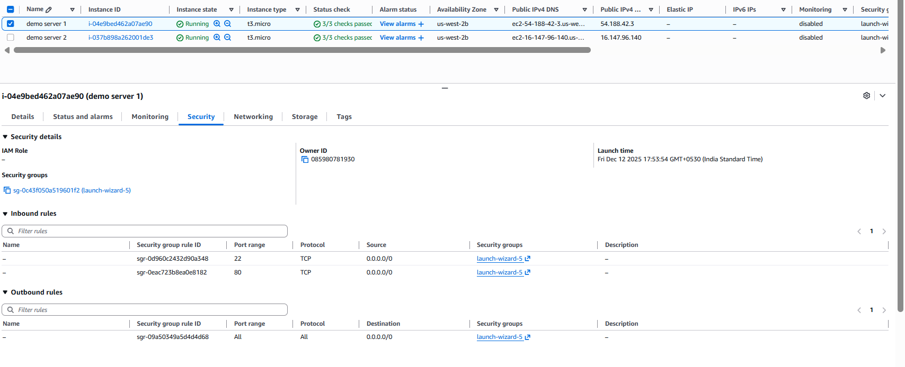
Target group
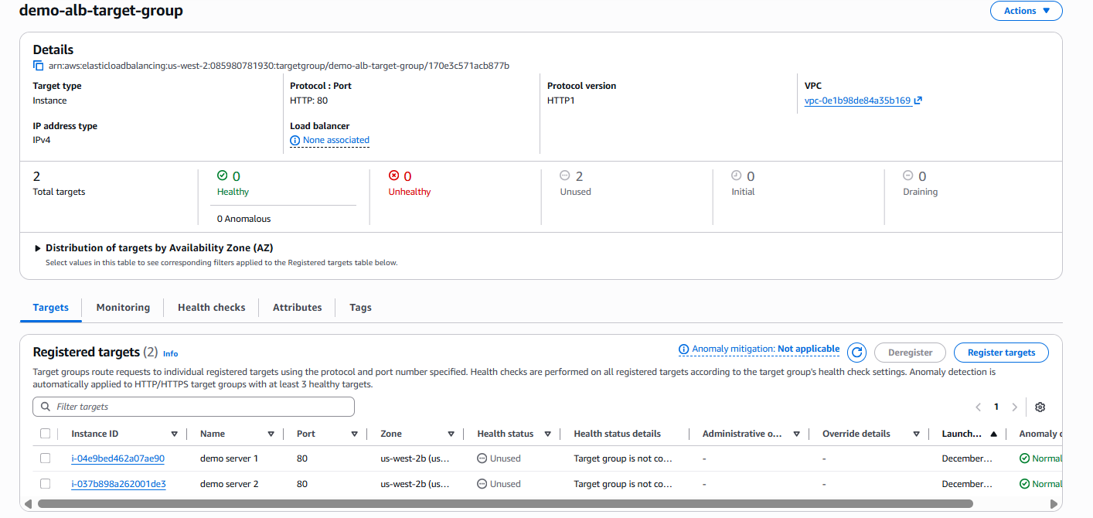
Load balancer
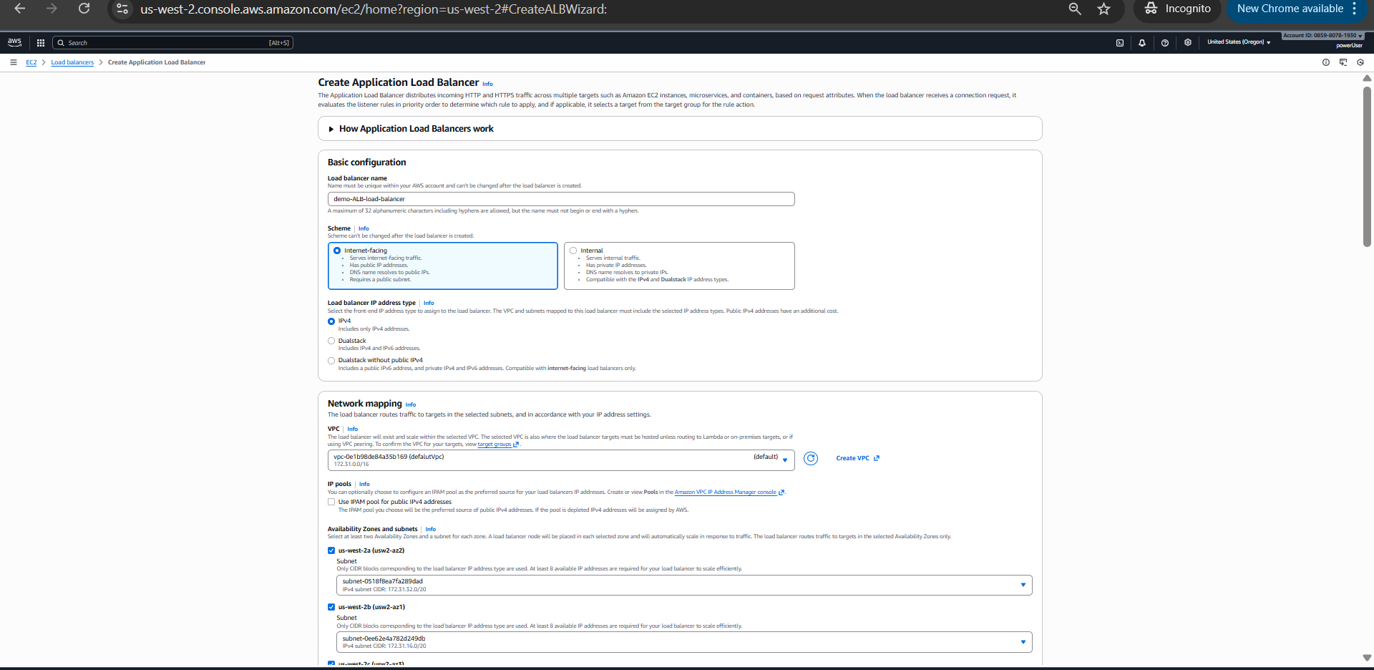
Security Groups ,Listners & Routing
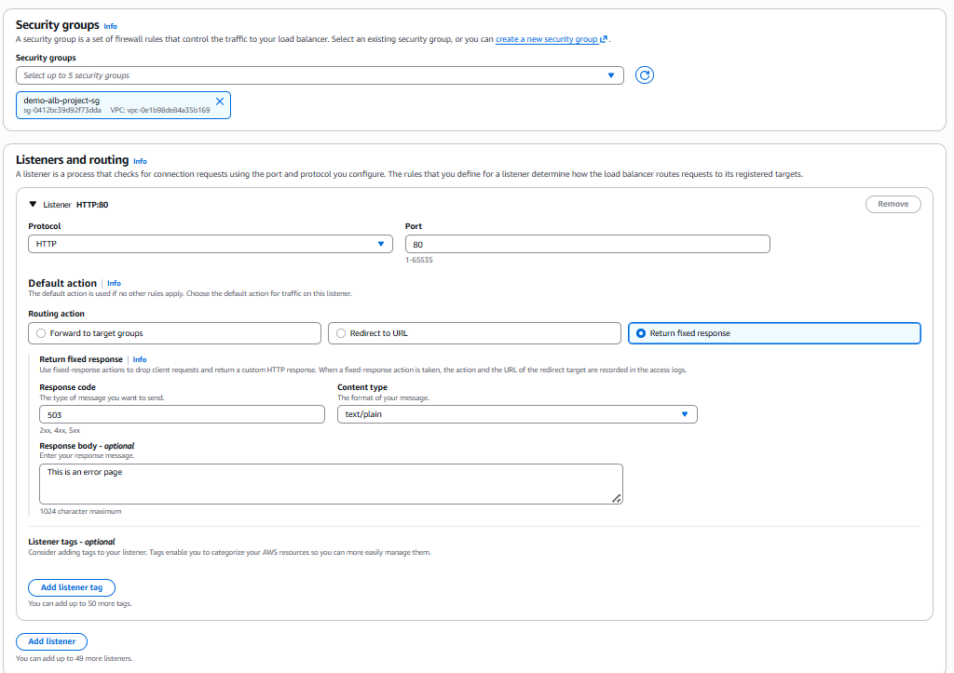
Ip’s Redirecting
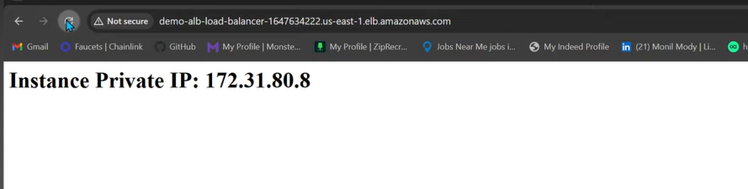
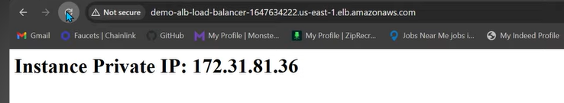
Listner rules
